# Design Overview for Music Player

Name: Ekrar Uddin Mohammed Efaz

Student ID: 103494172

# Summary of Program

I am working on Extension of Music Player for my Custom Program. Besides the 7.3D requirements I added a few more extensions that are listed below:

1. Display of Multiple Albums though Paging.

2. Player Control Buttons (Play,Pause,Skip,Volume,Repeat).

3. Player Scene and Menu Scene Separated

4. Adding Songs to Favourite Playlist and Accessing them from Menu.

5. Genre Sorted Tracks and a Genre Sort Menu.

6. File Select Prompt using “RubyTk” to select the album file.

7. Opens an External Music PLayer(VLC) *works on linux/mac only*

8. Can use the GUI version or CLI version using --gui/--cli command from terminal.

# Required Data Types

Describe each of the records and enumerations you will create using the following table (one per record).

Table 1: Album Record details

|  |  |  |
| --- | --- | --- |
| **Field Name** | **Type** | **Notes** |
| **id** | Integer | gives each album an unique id |
| **title** | string | title of the album |
| **artist** | string | name of the artist |
| **artwork** | Record | a record of album image |
| **genre** | integer | genre of the song |
| **tracks** | Record | each track is a record stored in an array |

Table 2: Track Record details

|  |  |  |
| --- | --- | --- |
| **Field Name** | **Type** | **Notes** |
| **name** | string | name of the track |
| **location** | string | stores location of the track in the current directory |

Table 3: Favorite Record details

|  |  |  |
| --- | --- | --- |
| **Field Name** | **Type** | **Notes** |
| **name** | string | name of the track added to favorites |
| **location** | string | location of the track in current directory |
| **artist** | string | name of the artist of song |

Table 4: Artwork Record details

|  |  |  |
| --- | --- | --- |
| **Field Name** | **Type** | **Notes** |
| **image** | Gosu Image Object | stores the gosu image object in an instance variable |

Table 5: ZOrder Enumeration details

|  |  |
| --- | --- |
| **Value** | **Notes** |
| **BACKGROUND,PLAYER,UI** | Stores ZOrder values of 0,1,2 respectively |

Table 6: Genre Enumeration details

|  |  |
| --- | --- |
| **Value** | **Notes** |
| **POP,CLASSIC,JAZZ,ROCK,METAL** | Stores Genres values of Albums in 0 to 4 respectively |

…

# Overview of Program Structure

List the main functions/procedures you are going to need to create this program. For each function/procedure provide its name and a brief description of what it will do.

Don’t spend too long on this at this stage. Focus on the main things you think you are likely to need and you can build on this as your program develops.

External libraries used:

1. RubyTk.

A Standard Graphical User Interface.

2. OptParse

Parses Commands Passed in from Terminal

3.vlc-client

To play music via external player(vlc) using system-call

A list of Required and Used functions are:

1.read_album_file(),read_album(),read_albums(),read_track(),read_tracks()

Album reading functions used from text music player.

2. read_tracks_by_genre(selected_genre)

Reads tracks by a selected genre

3. area_clicked(xL,yT,xR,yB)

Checks if an area was clicked. Takes in 4 arguments which determine the position coordinate of the area on the window.

4. draw_background()

draws the background of the player

5. draw_genre_box()

draws the genre menu option

6. draw_favorites_box()

draws the favorites menu option

7. draw_close_box()

draws the close button for the application

8. draw_page_button()

draws the paging buttons for the menu

9. draw_volume_rocker()

draws the volume rocker for the player scene

10. draw_back_button()

draws a button used to go to back to menu scene from other scenes

11. external_player_button()

draws the button to redirect to an external player

12. draw_buttons()

draws player control buttons like play/pause/forward etc.

13. display_tracks()

displays the tracks for a selected album

14. display_tracks_by_genre()

displays tracks but only by genre

15. display_favorite_tracks()

displays only favorite songs only when favorites album is selected

16. display_playing_track()

displays the currently playing track

17. draw_albums()

draws all the albums from the file in menu scene

18. draw_album()

draws the selected album in player scene

19. draw_menu()

draws the menu scene

20. draw()

default gosu draw function that contains all the above mentioned functions with few loops and conditionals to assist the drawing of the menu, player and genre_sort scenes.

21. menu_paging_click()

handles the click events of paging option in menu

22. close_application()

handles the click event of close button in menu scenes and closes the application.

23. favorites_album_click()

handles the click event of favorites album and redirects to a different scene.

24. genre_sort_click()

handles the click event of genre sort album and redirects to a different scene.

25. select_genre()

handles the clicks events of genre sort menu where user selects a genre to display all its tracks.

26. select_track_by_genre()

handles the click events in genre sort menu where user selects a track in a specific genre to play.

27. play_pause_click()

handles the player control click for play and pause button

28. forward_backward_click()

handles the player control click for skip song or go to previous song.

29. volume_click()

handles the volume rocker button clicks and changes volume accordingly

30. keyboard_play_pause()

Handles keyboard input from space bar to play/pause the current song

31. keyboard_mute()

Handles keyboard input from M to mute the volume

32. add_to_favorites()

handles the add to liked songs button click and adds the song to favorites album

33. repeat_click()

handles the click event of repeat button and repeats a song accordingly

34. player_controls_click()

takes all the player controls click event functions into one function.

35. player_scene_click_events()

handles all the click event functions for the player scene including the

36. button_down(id)

default gosu function for detecting mouse clicks.

37. play_track(track,album)

plays track when called, takes two parameters which are the current track to be played and which album it belongs to.

38. play_track_by_genre(current_track)

plays tracks from the genre sort menu when called with a parameter which is the current track played.

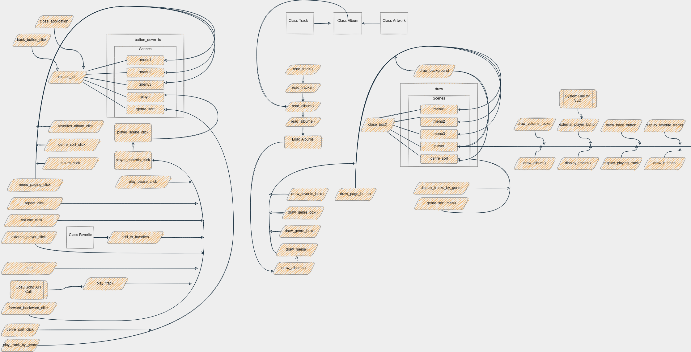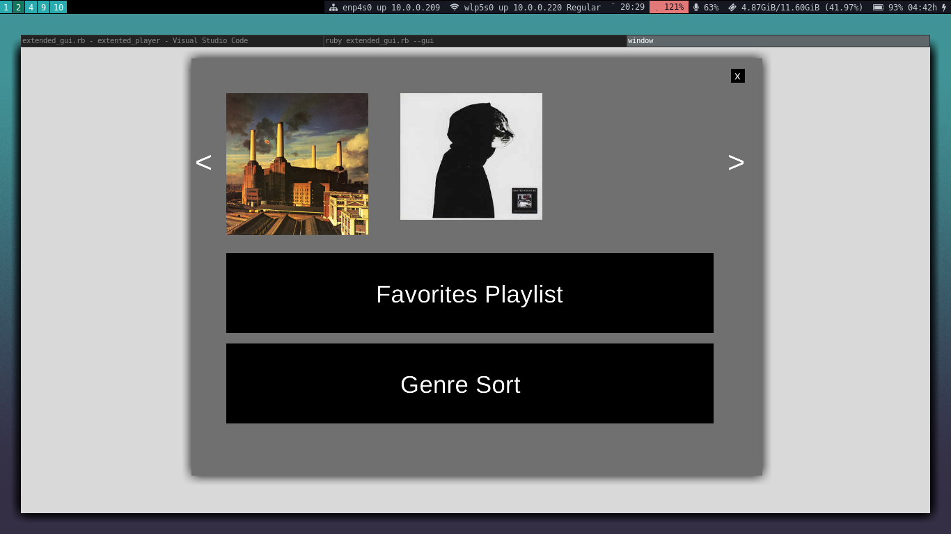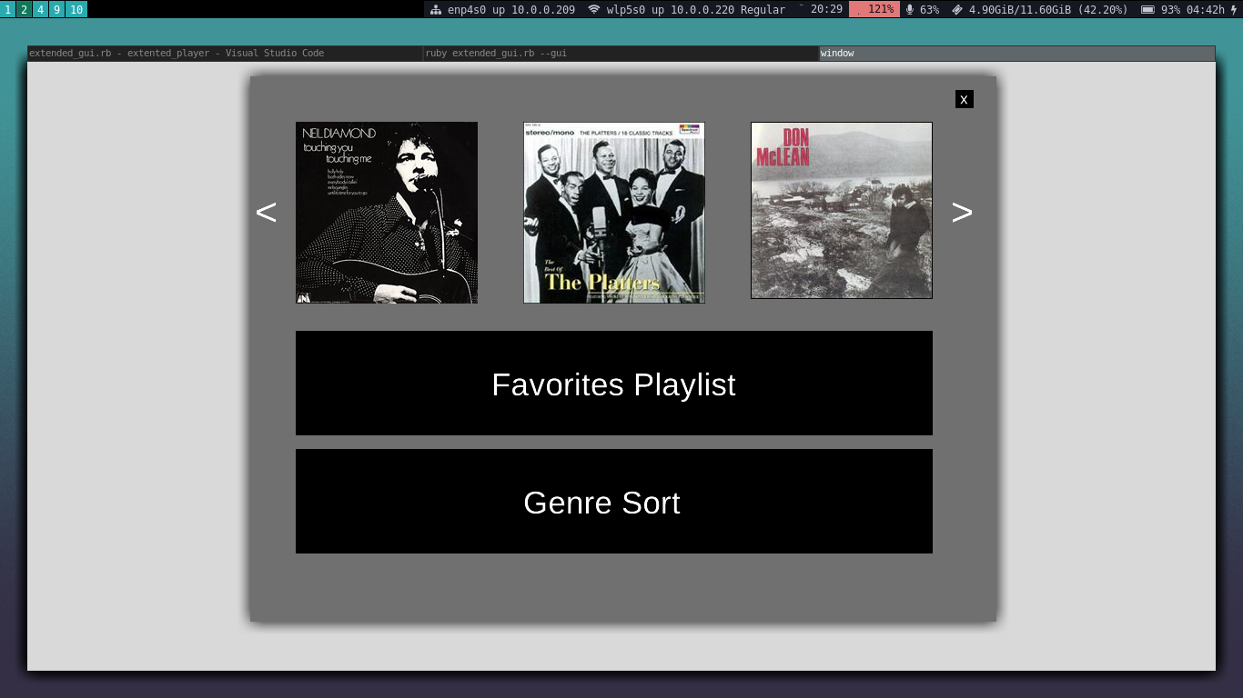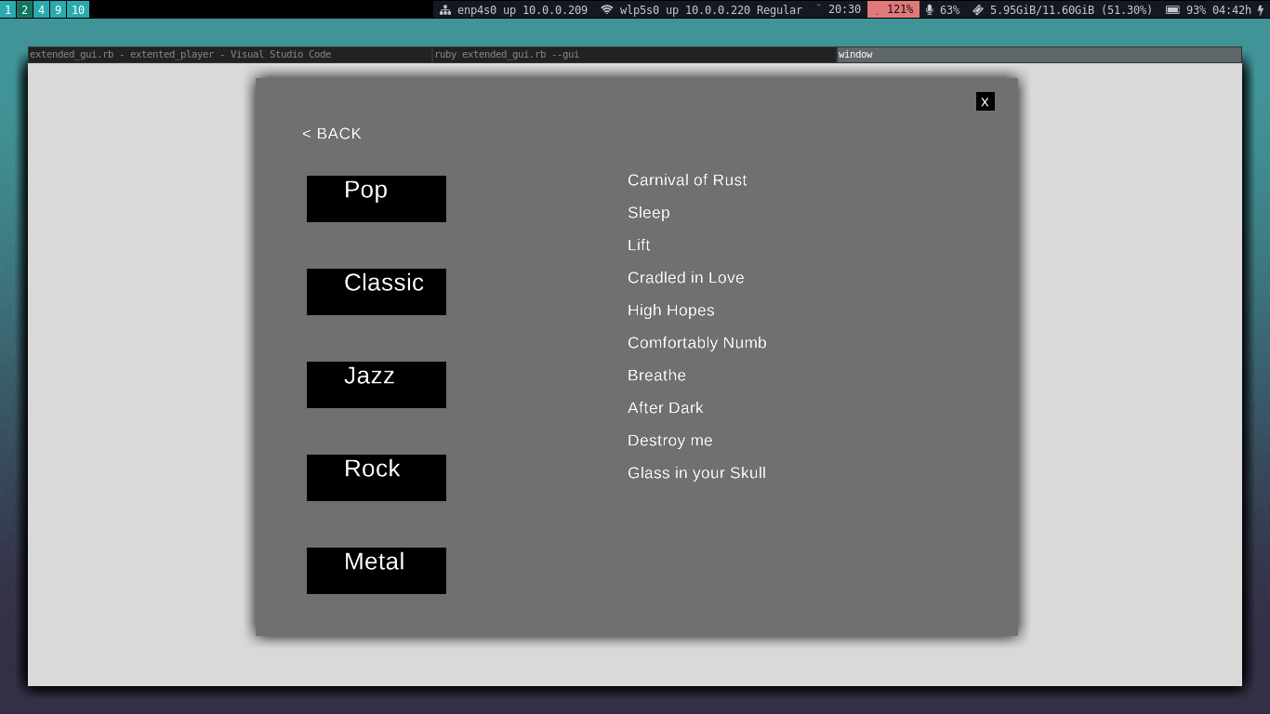 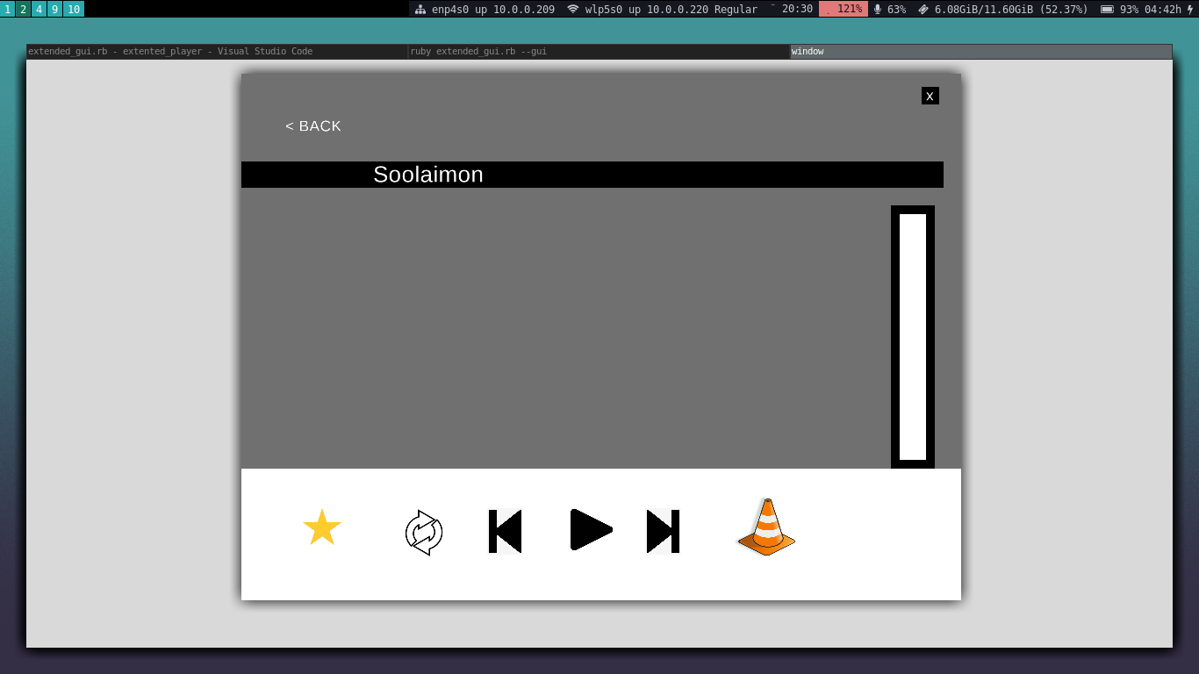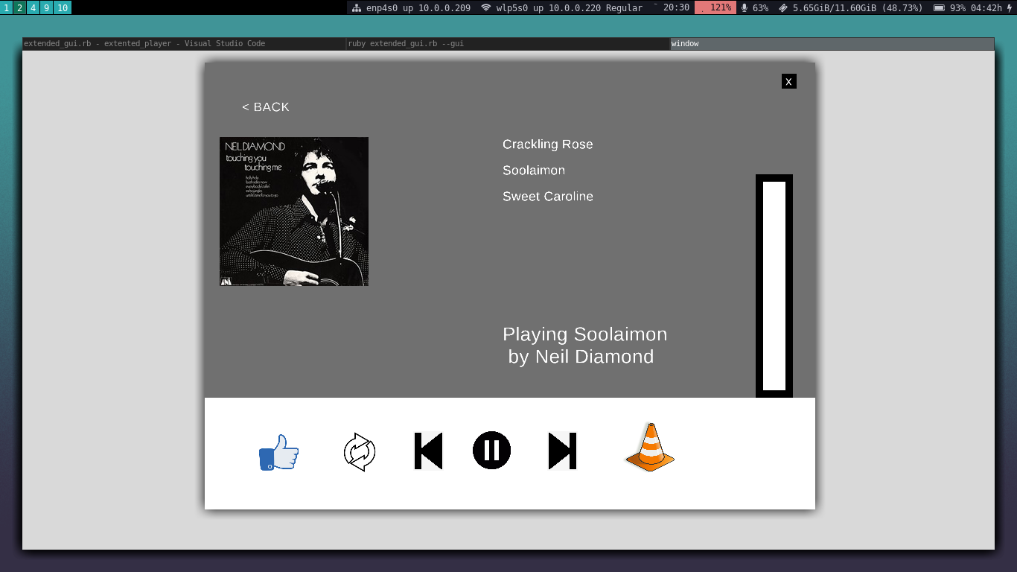Structure chart for Extended Music Player